How to change SSH port in Ubuntu:

-Edit the SSHD configuration file:
sudo vim /etc/ssh/sshd_config

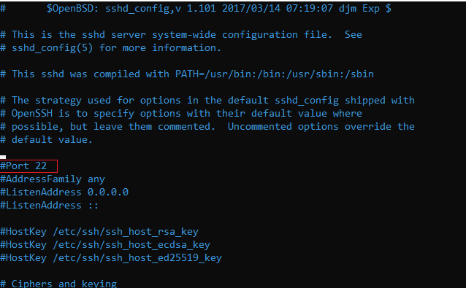
-Uncomment the above line (if not commented). Then change the port from 22 to 23. The final statement looks as follows:
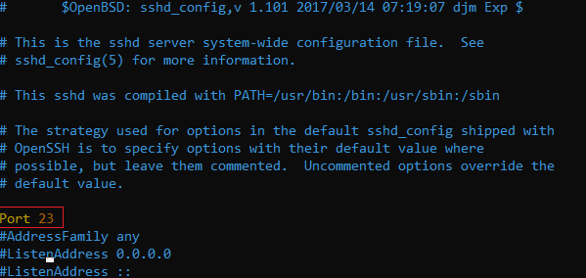

sudo service ssh restart
Once the service is restarted, you can exit out and re-login to the VM on port 23.
Now, To SSH to the VM on port 23:
sudo ssh -p 23 ubuntu@1.2.3.4

